**[7 Detox Smoothies With Added Health Benefits](http://girlgetstrong.com/2011/10/10/7-detox-smoothies-with-added-health-detox-benefits/)**

By [Sian](http://girlgetstrong.com/author/gogo-girl/) on Oct 10, 2011 with [Comments 25](http://girlgetstrong.com/2011/10/10/7-detox-smoothies-with-added-health-detox-benefits/#comments)

[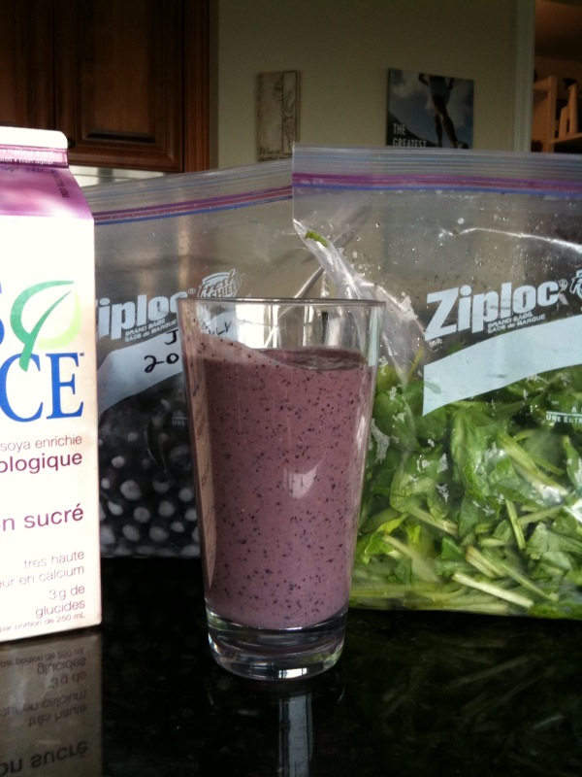](http://girlgetstrong.com/wp-content/uploads/2009/08/greenish-monster.jpg)Smoothies are a great way to boost your fruits and veggies daily intake.  It makes a delicious quick breakfast, a nice refreshing snack, a wonderful healthy dessert or a super post-training drink.  Not only the flavor combinations are infinite, you can prepare different recipes to benefit from specific health components from its ingredients.  One other great thing about smoothies is that to the opposite of simple juices, it keeps all the natural fiber, which help cleansing the digestive tract.  The powerful detox foods that go into it help your liver to detox naturally, and they can help you stay healthy and look great.

**Flat Tummy**

Rich in digestion supporting ingredients, this smoothie will help prevent bloating and digestive stress that can sabotage your tummy flattening efforts.

* 3/4 c. papaya
* 3/4c. sliced peaches
* 1/2 pear, sliced
* 1 tsp fresh ginger
* 2 mint leaves
* Water to thin

**Skin Saver**

Antioxidants in berries are known to help to fight wrinkles and other skin ageing signs.  Berries are also a great way to control blood sugar that can sabotage your complexion.  This smoothie also contains Omega 3, to fight inflammation, as well as vitamins E and C, both renown to help the skin.

* 3/4 c blueberries
* 3/4 c pitted cherries
* 5   strawberries
* 1/4 avocado, peeled and pitted
* 2 tsp wheat germ (optional)
* 2 tsp ground flaxseed
* Water, to thin

**Peanut Butter Energy Booster**

This protein-rich and minerals-filled smoothie will give you long-lasting energy.  Cinnamon will help to control your blood sugar so your energy level won’t crash too quickly.

* 1 big banana
* 1 scoop of natural hemp protein powder
* 2 tsp of natural peanut butter
* 1 handful of fresh baby spinach
* 1/2 tsp of cinnamon
* Water, to thin

**Bone Lover**

This vitamin-rich green smoothie contains calcium, magnesium and other bone building minerals to keep your bone strong and healthy.

* 2 bananas
* 1 handful of Swiss chard leaves, stems removed
* 1 handful of kale leaves
* 1 tsp of green Matcha powder
* 1/2 cup of homemade almond milk

**Immune System Booster**

Rich in vitamin A, C and zinc, this smoothie can increase the production of white blood cells and antibodies to get your body ready to resist this season’s infections.

* 1/2 c. mango cubes
* 1/2 c. cantaloupe cubes
* 1/2 c. fresh pineapple cubes
* 1/4 c. chopped pumpkin seeds
* Water, to thin

**Natural Skin Tanner**

Studies have proven that a beta-carotene rich diet can make your complexion glow, and that particular skin tone is usually considered healthier than a regular skin tan. This smoothie can help you get that healthy glow without risking your skin lying under the sun.

* 1/2 cup of cantaloupe cubes
* 1/2 cup of papaya
* Juice of 1 orange
* 1/2 cup of carrot juice (or water)
* 1 small knob of fresh ginger

**Antioxidant Power**

Feel the power of this detox foods-rich smoothie.  Very rich in antioxidants, this smoothie will help to support your liver to detox naturally and help your body stay healthy and young longer.

* 1/3 cup of blueberries
* 1/3 cup of raspberries
* 1/3 cup of pomegranate kernels
* 1/4 cup of beet juice (optional)
* 1 banana
* Water to thin